

After Hour
Reasonable Suspicion
Drug Testing Procedure

The City of Stamford has contracted with Drug Test Compliance to perform on-site drug and alcohol testing when reasonable suspicion has been confirmed. Currently only Drug Test Compliance is completing the breathalyzer for reasonable suspicion, so we will have to have them come up for a one time visit.

For Cause Determination Process
- Move employee to a private area; ensure that one other supervisor or manager is present.

- Contact the on-site manager or human resources, Reasonable suspicion must be corroborated.
Complete the Reasonable Suspicion Assessment (prior to employee drug or alcohol testing) by two members of management / supervisor(s) who have had first-hand observation. Results will determine if reasonable suspicion exists. Please review questions on 2nd page of this Standard Operating Procedure.

Drug Test Compliance
Business Hours 8AM-5PM 914 250 1420
After-Hours 5PM-8AM 914 414 3118
After Hours (backup) 914 318 6602

- Human Resource or site manager will contact Drug Test Compliance; provide contact information, and situational details.
- Drug Test Compliance will confirm arrival time and provide the collector contact information. Arrival times can differ between 30 minutes – 2 hours.
- Drug Negative results are available in 24 hours, and results are emailed to HR Manager.
- BAC Breathalyzer results should be known immediately after test.
- Positive results may take up to 72 hours before available.
Positive results require that the Medical Review Officer reach out to the employee, which can take up to 3 days.

LAB: Quest –
DOT: # 10559656
NDOT: # 10559660
The City of Stamford
DER: Matt Stuhlman
888 Washington Boulevard
Stamford CT 06901
203-977-4908
Cell: 203-424-4178
MRO: David Nahin, MD
I3 Screen
9501 Northfield Blvd
Denver CO, 80238
Phone: 877-585-7366
Fax: 855-253-5666

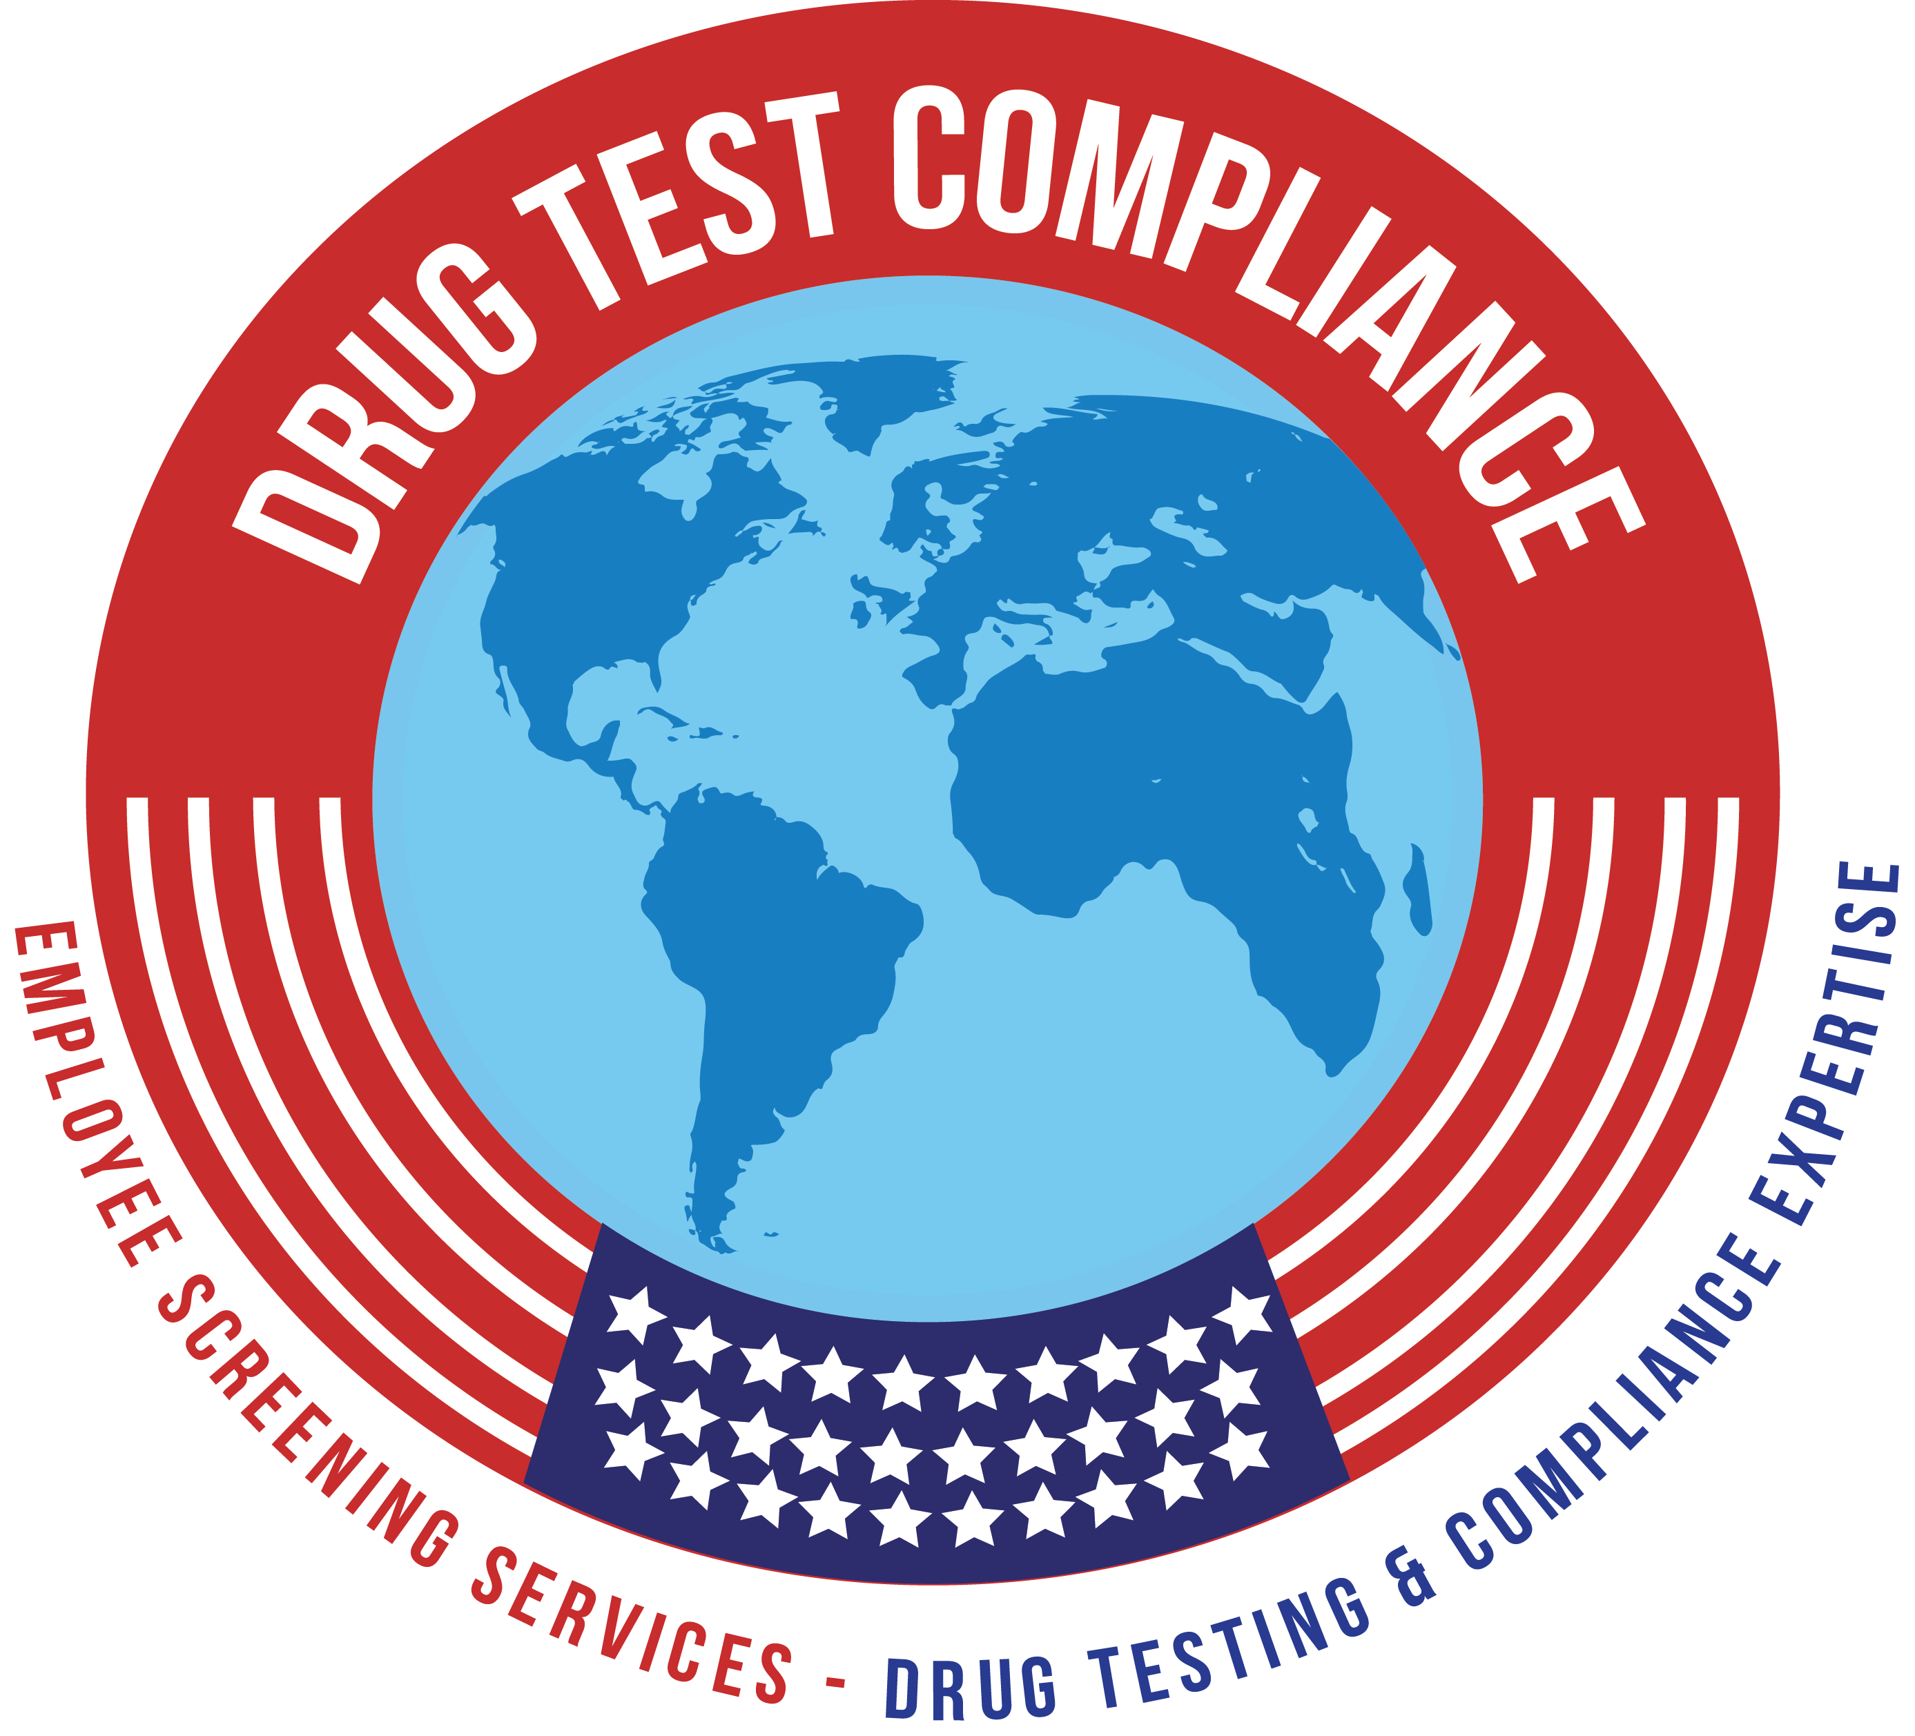
Drug Test Compliance
1200 East Bay Ave
Bronx, NY 10474
Tel. (914)250-1420
E-Mail: info@drugtestcompliance.com
www.DrugTestCompliance.com

